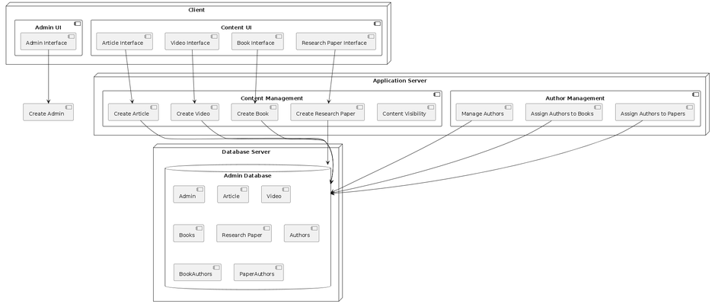

The deployment diagram illustrates the architecture of the content management system, focusing on the interactions between various system components and their deployment environments.

* **Database Server**: This node contains the main **Admin Database**, which stores all the critical entities, including Admin, Article, Video, Books, Research Paper, Authors, BookAuthors, and PaperAuthors. These entities represent the core data stored and managed within the system.
* **Application Server**: This node hosts two key components:
  1. **Content Management**: Responsible for creating and managing content such as articles, videos, books, and research papers. It also includes functionality for setting content visibility (e.g., public or members-only).
  2. **Author Management**: Manages the creation and assignment of authors to books and research papers, ensuring that each piece of content is properly associated with its creator.
* **Client**: The client node contains two user interface components:
  1. **Admin UI**: Allows administrators to manage users, create new content, and assign visibility settings.
  2. **Content UI**: Provides interfaces for managing articles, videos, books, and research papers.

**Interactions**

* The **Admin Interface** in the **Client** communicates with the Create Admin feature, while the **Content UI** interacts with the Create Article, Create Video, Create Book, and Create Research Paper features.
* Both **Content Management** and **Author Management** components interact with the **Admin Database** to store and retrieve relevant data.